**DAILY ONLINE ACTIVITIES SUMMARY**

|  |  |  |  |  |  |  |  |  |
| --- | --- | --- | --- | --- | --- | --- | --- | --- |
| **Date:** | **09/06/2020** | | | | | **Name:** | **Manish B Shriyan** | |
| **Sem & Sec** | **8th sem B sec** | | | | | **USN:** | **4AL16CS131** | |
| **Online Test Summary** | | | | | | | | |
| **Subject** | | **BDA** | | | | | | |
| **Max. Marks** | | **30** | | **Score** | | | **25** | |
| **Certification Course Summary** | | | | | | | | |
| **Course** | **1)Amazon SageMaker: Build an Object Detection Model Using Images Labeled with Ground Truth**  **2)AWS Lambda Foundations** | | | | | | | |
| **Certificate Provider** | | | **AWS** | | **Duration** | | | **2 Hours 10 Mins** |
| **Coding Challenges** | | | | | | | | |
| **Problem Statement:**  **Write a C Program to rotate the matrix by K times** | | | | | | | | |
| **Status: Solved** | | | | | | | | |
| **Uploaded the report in Github** | | | | | **Uploaded** | | | |
| **If yes Repository name** | | | | | **ManishShriyan** | | | |
| **Uploaded the report in slack** | | | | | **Yes** | | | |

Online Test Details:



Certification Course Details:

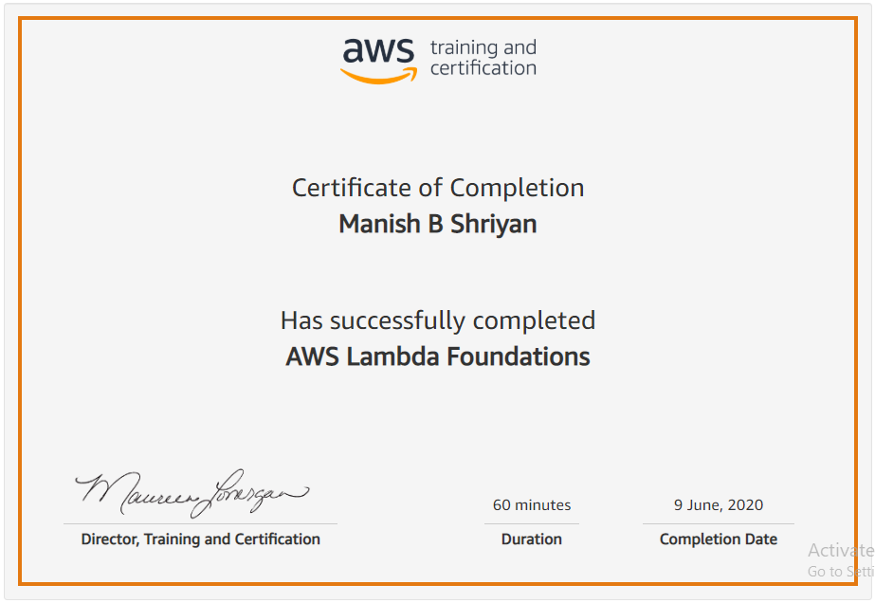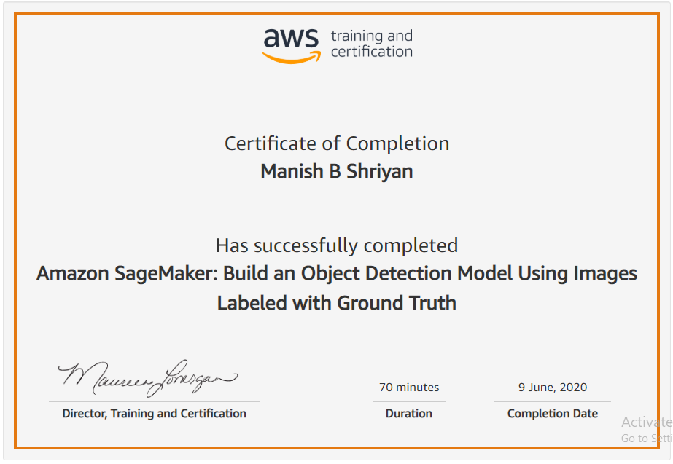

Coding Challenges Details:

|  |
| --- |
|  |
|  |  |
|  |  |
|  |  |
|  |  |
|  |  |
|  |  |
|  |  |
|  |  |
|  |  |
|  |  |

#include <stdio.h>

void shiftArrPos(int *arr, int arrSize)

{

int i, temp;

temp = arr[0];

for(i = 0; i < arrSize-1; i++)

{

arr[i] = arr[i+1];

}

arr[i] = temp;

}

void arrRotate(int *arr, int arrSize, int rotFrom)

{

int i;

for(i = 0; i < rotFrom; i++)

{

shiftArrPos(arr, arrSize);

}

return;

}

int main()

{

int arr[10][10];

int i, j, K, n1, n2;

printf("Enter the size of the matrix: ");

scanf("%d%d",&n1,&n2);

printf("Enter the Elements of the matrix:\n");

for(i = 0; i < n1; i++)

for(j = 0; j < n2; j++)

scanf("%d",&arr[i][j]);

printf("Enter the value of K: ");

scanf("%d", &K);

printf("Matrix before rotation\n");

for(i = 0; i < n1; i++)

{

for(j = 0; j < n2; j++)

printf("%d ",arr[i][j]);

printf("\n");

}

for(i = 0; i < n1; i++)

arrRotate(arr[i], n2, K);

printf("Matrix after rotation\n");

for(i = 0; i < n1; i++)

{

for(j = 0; j < n2; j++)

printf("%d ",arr[i][j]);

printf("\n");

}

return 0;

}